Software Requirements Specification
for
Electronic Barkeeper
Version 1.1 approved
Prepared by Team 8 (Andreas Schön, Krist Stoja & Tobias Bartsch)
Chair of operating systems
19.11.2017
Table of Contents
Table of Contents ii
Revision History ii
1. Introduction 1
1.1 Purpose 1
1.2 Document Conventions 1
1.3 Intended Audience and Reading Suggestions 1
1.4 Product Scope 1
1.5 References 1
2. Overall Description 2
2.1 Product Perspective 2
2.2 Product Functions 2
2.3 User Classes and Characteristics 2
2.4 Operating Environment 2
2.5 Design and Implementation Constraints 2
2.6 User Documentation 2
2.7 Assumptions and Dependencies 3
3. External Interface Requirements 3
3.1 User Interfaces 3
3.2 Hardware Interfaces 3
3.3 Software Interfaces 3
3.4 Communications Interfaces 3
4. System Features 4
4.1 System Feature 1 4
4.2 System Feature 2 (and so on) 4
5. Other Nonfunctional Requirements 4
5.1 Performance Requirements 4
5.2 Safety Requirements 5
5.3 Security Requirements 5
5.4 Software Quality Attributes 5
5.5 Business Rules 5
6. Other Requirements 5
Appendix A: Glossary 5
Appendix B: Analysis Models 5
Appendix C: To Be Determined List 6

Revision History
Name | Date | Reason For Changes | Version
Team 8 | 11.11.2017 | Initial Draft | 1.0
Team 8 | 19.11.2017 | Final Version | 1.1

Introduction

Purpose
<Identify the product whose software requirements are specified in this document, including the revision or release number. Describe the scope of the product that is covered by this SRS, particularly if this SRS describes only part of the system or a single subsystem.>

In the original sense the purpose of this project is to get in touch with android development. To give this project a more useful approach we develop a rudimentary electronic barkeeper with the Tinkerkit Robotic arm controlled by an android device that utilizes an Arduino microcontroller. The revision number and release number will be 1.0 in the end.

Document Conventions
<Describe any standards or typographical conventions that were followed when writing this SRS, such as fonts or highlighting that have special significance. For example, state whether priorities for higher-level requirements are assumed to be inherited by detailed requirements, or whether every requirement statement is to have its own priority.>

Underlines mark new paragraph or logical separations.
Bold fonts mark important information that need to be stressed additionally.
The “optional” keyword in front of a text paragraph marks parts of the software that will only be realized if there is enough time to do so.

Intended Audience and Reading Suggestions
<Describe the different types of reader that the document is intended for, such as developers, project managers, marketing staff, users, testers, and documentation writers. Describe what the rest of this SRS contains and how it is organized. Suggest a sequence for reading the document, beginning with the overview sections and proceeding through the sections that are most pertinent to each reader type.>

This document is produced as way to track the original and the upcoming requirements. Therefore it mainly produced for those who want to understand the project and what was done or for those who needs to have a good overview.

Product Scope
<Provide a short description of the software being specified and its purpose, including relevant benefits, objectives, and goals. Relate the software to corporate goals or business strategies. If a separate vision and scope document is available, refer to it rather than duplicating its contents here.>

The electronic barkeeper is a standalone research project without any corporate goals or business strategies at this point. The main goal is to enable the Tinkerkit Robotic Arm to get controlled by speech recognition and voice commands via an android device. Keeping this in mind the electronic barkeeper should therefore be able to recognize and match different alcoholic and non-alcoholic beverages in the real world with the ones saved in the database.

Optional: In the broader sense the robotic arm should then pass you accordingly the wished drink automatically by searching the demanded drink amongst a line of prepared possibilities. The sole purpose of this arm is to facilitate a barkeepers daily work by letting him concentrate on the mixing of the drinks and not on the ordering process.

References
<List any other documents or Web addresses to which this SRS refers. These may include user interface style guides, contracts, standards, system requirements specifications, use case documents, or a vision and scope document. Provide enough information so that the reader could access a copy of each reference, including title, author, version number, date, and source or location.>

- Arduino Tinkerit Braccio Robotic Arm: https://store.arduino.cc/tinkerkit-braccio

- Tinkerit Braccio Robotic Arm: http://docs-europe.electrocomponents.com/webdocs/14da/0900766b814da22f.pdf

- Bluetooth Shield V2.0: http://wiki.seeedstudio.com/wiki/Bluetooth_Shield_V2.0

- Color detector: https://www.banggood.com/de/GY-31-TCS3200-TCS230-Color-Recognition-Sensor-Color-Detector-Module-for-Arduino-p-1145105.html

- https://www.amazon.de/adafruit-sensore-TCS34725-RGB-Fernbedienung-Infrarot-Filter/dp/B00OKCRU5M/ref=sr_1_3?s=ce-de&ie=UTF8&qid=1510659787&sr=1-3&keywords=RGB+Color+Sensor+For+Arduino

- https://create.arduino.cc/projecthub/mjrobot/arduino-color-detection-57e4ce?ref=tag&ref_id=color%20sensor&offset=0

- Alcohol sensor: https://www.amazon.de/Methan-Wasserstoff-Alkohol-Arduino-Raspberry/dp/B071RR7XZY/ref=sr_1_1?ie=UTF8&qid=1510653218&sr=8-1&keywords=arduino+sensor+alkohol

- Android Material Design: https://material.io/guidelines/

Overall Description

Product Perspective
<Describe the context and origin of the product being specified in this SRS. For example, state whether this product is a follow-on member of a product family, a replacement for certain existing systems, or a new, self-contained product. If the SRS defines a component of a larger system, relate the requirements of the larger system to the functionality of this software and identify interfaces between the two. A simple diagram that shows the major components of the overall system, subsystem interconnections, and external interfaces can be helpful.>

This system will consist of two parts: the hardware part with the Arduino Robotic Arm and its sensors and the software part with the User Interface on Android Operating System.

The two parts will be connected together through Bluetooth, which will be made possible through a Bluetooth Shield attached to the Arduino chip. While the Arduino will use the Bluetooth channel to send data collected from its sensors, the UI will use it to control the Arm either manually or with pre-programmed movements. The commands will be voice controlled, made possible from the integrated Voice Controller of the Android Operating System.

Product Functions
<Summarize the major functions the product must perform or must let the user perform. Details will be provided in Section 3, so only a high level summary (such as a bullet list) is needed here. Organize the functions to make them understandable to any reader of the SRS. A picture of the major groups of related requirements and how they relate, such as a top level data flow diagram or object class diagram, is often effective.>

The most basic function made through the mobile application will be the simple movements of the arm in the all possible space. In addition to that, using the data gathered from the detection, pressure, color detector and alcohol sensor, the arm will be able to detect and move object and also separate them from their color and alcohol compound, if being commanded to do so from the application.

User Classes and Characteristics
<Identify the various user classes that you anticipate will use this product. User classes may be differentiated based on frequency of use, subset of product functions used, technical expertise, security or privilege levels, educational level, or experience. Describe the pertinent characteristics of each user class. Certain requirements may pertain only to certain user classes. Distinguish the most important user classes for this product from those who are less important to satisfy.>

Since this product is a prototype and not an end-product, the purpose will be to test different functionalities possible between an Arduino chip and an Android Operating System. There aren't any user classes that will use or make use of it.

Operating Environment
<Describe the environment in which the software will operate, including the hardware platform, operating system and versions, and any other software components or applications with which it must peacefully coexist.>

The Arduino chip is of the Arduino Uno version, which will have a Bluetooth Shield attached in order to make possible the coexistence with the software. The sensors used must also be compatible with the Arduino Uno chip. The controlling device will have to be equiped with an Android software of at least version 6.0, also, if possible, with the Bluetooth version 5.0, in order to make multiple pairing possible.

Design and Implementation Constraints
<Describe any items or issues that will limit the options available to the developers. These might include: corporate or regulatory policies; hardware limitations (timing requirements, memory requirements); interfaces to other applications; specific technologies, tools, and databases to be used; parallel operations; language requirements; communications protocols; security considerations; design conventions or programming standards (for example, if the customer’s organization will be responsible for maintaining the delivered software).>

The constrains of the product depend on the capability of the sensors of gathering the required data and providing them for the system. Another constrain is the version of Android Operating System, which has to provide us the data from the Voice Controller. There are not other constrains thought, since the operations planned are supported by the used Arduino chip and Operating System.

User Documentation
<List the user documentation components (such as user manuals, on-line help, and tutorials) that will be delivered along with the software. Identify any known user documentation delivery formats or standards.>

Assumptions and Dependencies
<List any assumed factors (as opposed to known facts) that could affect the requirements stated in the SRS. These could include third-party or commercial components that you plan to use, issues around the development or operating environment, or constraints. The project could be affected if these assumptions are incorrect, are not shared, or change. Also identify any dependencies the project has on external factors, such as software components that you intend to reuse from another project, unless they are already documented elsewhere (for example, in the vision and scope document or the project plan).>

We assume that the sensors provided are compatible with the Arduino Uno chip and that they will provide us correctly the expected data. We also assume that the data gathered from the Voice Controller of Android will be usable for our purposes of giving commands to the Arm through the User Interface.

External Interface Requirements

User Interfaces
<Describe the logical characteristics of each interface between the software product and the users. This may include sample screen images, any GUI standards or product family style guides that are to be followed, screen layout constraints, standard buttons and functions (e.g., help) that will appear on every screen, keyboard shortcuts, error message display standards, and so on. Define the software components for which a user interface is needed. Details of the user interface design should be documented in a separate user interface specification.>

For the GUI a simple interface without any user authentication is used. We follow the material design guidelines.

Hardware Interfaces
<Describe the logical and physical characteristics of each interface between the software product and the hardware components of the system. This may include the supported device types, the nature of the data and control interactions between the software and the hardware, and communication protocols to be used.>

3 protocols: UART(Universal asynchronus receiver transmitter), SPI (Serial Peripheral Interface), and I2C (inter integrated circuit)

Scsi (small computer system interface)

ADC (Analog digital converter) for sensors

PCI express (peripheral component interconnect express)

The Arduino uno R3 is used as the micro controller to connect the robotic arm and the android device. Any Android device can be used with Bluetooth 4.0 or higher. Those versions already include Classic Bluetooth, Bluetooth high speed and Bluetooth low energy protocols. In order to get the signal from received from our android device, a Bluetooth Shield V2.0 is mounted. To communicate with our Arduino Uno R3, you can choose two pins from Arduino D0 to D7 as Software Serial. Whereas D0 and D1 are Hardware Serial Ports. The robotic arm is connected to the Arduino Uno R3 via a USB Port. The lowest supported Version is USB 2.0. Sensors use the I/O pins of the Arduino as connectors and are so limited. For starters a color sensor, the adafruit-sensore TCS34725 RGB is facilitated. Optionally a gas alcohol detector is utilized to further increase the detection accuracy.

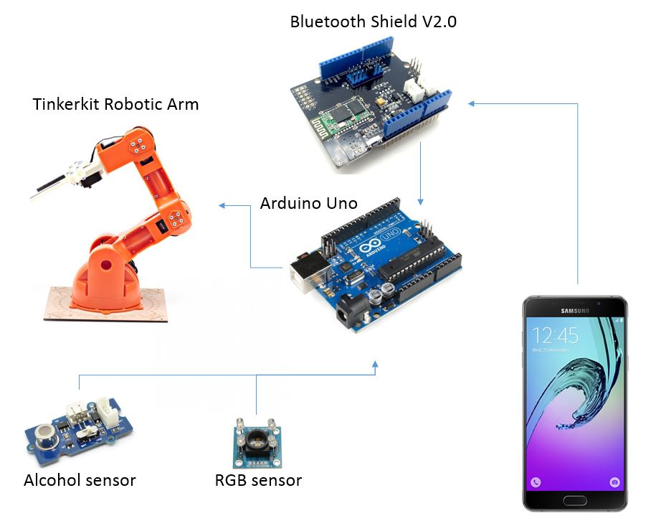

Software Interfaces
<Describe the connections between this product and other specific software components (name and version), including databases, operating systems, tools, libraries, and integrated commercial components. Identify the data items or messages coming into the system and going out and describe the purpose of each. Describe the services needed and the nature of communications. Refer to documents that describe detailed application programming interface protocols. Identify data that will be shared across software components. If the data sharing mechanism must be implemented in a specific way (for example, use of a global data area in a multitasking operating system), specify this as an implementation constraint.>

The used software parts to create and run the system are:
- Android Studio IDE
- Android OS
- Google Voice Recognition
- Arduino Uno sketch
- Arduino Braccio library
- Arduino Servo library
- Arduino IDE

The purpose of each component is:

Android Studio IDE: This tool is required to build the main application with the user interface, with will process input by the user and return outputs.

Android OS: The Android OS is required to run the application build in the IDE.

Google Voice Recognition: This feature provided by the Google application can be used with an intent to implement voice recognition.

Arduino Uno sketch: The sketch is a small program uploaded to the Arduino Uno, which makes it possible to communicate with the Android application and perform actions with the Arduino Braccio.

Arduino Braccio library: This library is necessary to create commands for the Arduino Braccio within the Arduino Uno sketch.

Arduino IDE: This IDE is used to create Arduino sketches and upload them to Arduino Uno.

Communications Interfaces
<Describe the requirements associated with any communications functions required by this product, including e-mail, web browser, network server communications protocols, electronic forms, and so on. Define any pertinent message formatting. Identify any communication standards that will be used, such as FTP or HTTP. Specify any communication security or encryption issues, data transfer rates, and synchronization mechanisms.>

System Features
<This template illustrates organizing the functional requirements for the product by system features, the major services provided by the product. You may prefer to organize this section by use case, mode of operation, user class, object class, functional hierarchy, or combinations of these, whatever makes the most logical sense for your product.>

The system features are separated in mandatory and optional ones. The core features are deemed mandatory and so need be realized satisfactorily in the end of the project. Optional features on the other hand can be implemented depending on the possibilities. During the creation of mandatory features, easy extendibility with optional features will be considered.

Mandatory: Voice control
The user is able to put in commands by talking to the Android application. This includes activating predefined movement patterns, as well as controlling the joints of the robotic arm individually. Voice control may be activated through a button in the user interface. The most important requirements of this feature is easy usability which includes intuitive commands with high controlling power and low error rate when recognizing speech.

Mandatory: Bluetooth connection
The application is connected to Arduino Uno with Bluetooth connection. This allows the user to move freely through the room without being restricted to a cable. The connection should be stable and easy to create for the user.

Mandatory: Colour detection
With a colour sensor attached to the gripper of the robotic arm the application should be able to detect which colour is in front of the sensor and tell the user or use this information to execute further actions. The variety of detectable colours should be high but will be limited by the sensor hardware.

Mandatory: User interface
The application has a user interface which should be easy to use and provide the user with all necessary information.

Optional: Alcohol detection
Similar to the colour sensor, an alcohol sensor attached to the gripper should recognize whether there is alcohol in the liquid or not. Those information can be used by the user to execute further actions. The accuracy should be high but will be limited by the sensor hardware.

Optional: Drink detection
Through the combination of the information provided by colour detection and alcohol detection the application should be able to recognize and differentiate between different drinks by comparing the senor values with a small set of predefined data.

Optional: Drink serving
The user should be able to name a drink through voice control. The Arduino Braccio will apply drink detection on different drinks, grab a drink which is detected as a correct one, and hand it to the user.

<Don’t really say “System Feature 1.” State the feature name in just a few words.>
4.1.1 Description and Priority
<Provide a short description of the feature and indicate whether it is of High, Medium, or Low priority. You could also include specific priority component ratings, such as benefit, penalty, cost, and risk (each rated on a relative scale from a low of 1 to a high of 9).>
4.1.2 Stimulus/Response Sequences
<List the sequences of user actions and system responses that stimulate the behavior defined for this feature. These will correspond to the dialog elements associated with use cases.>
4.1.3 Functional Requirements
<Itemize the detailed functional requirements associated with this feature. These are the software capabilities that must be present in order for the user to carry out the services provided by the feature, or to execute the use case. Include how the product should respond to anticipated error conditions or invalid inputs. Requirements should be concise, complete, unambiguous, verifiable, and necessary. Use “TBD” as a placeholder to indicate when necessary information is not yet available.>

<Each requirement should be uniquely identified with a sequence number or a meaningful tag of some kind.>

REQ-1:
REQ-2:

Other Nonfunctional Requirements

Performance Requirements
<If there are performance requirements for the product under various circumstances, state them here and explain their rationale, to help the developers understand the intent and make suitable design choices. Specify the timing relationships for real time systems. Make such requirements as specific as possible. You may need to state performance requirements for individual functional requirements or features.>

- No micro bucking caused by interfering signal

Safety Requirements
<Specify those requirements that are concerned with possible loss, damage, or harm that could result from the use of the product. Define any safeguards or actions that must be taken, as well as actions that must be prevented. Refer to any external policies or regulations that state safety issues that affect the product’s design or use. Define any safety certifications that must be satisfied.>

Security Requirements
<Specify any requirements regarding security or privacy issues surrounding use of the product or protection of the data used or created by the product. Define any user identity authentication requirements. Refer to any external policies or regulations containing security issues that affect the product. Define any security or privacy certifications that must be satisfied.>

- Fingerprint sensor?

Software Quality Attributes
<Specify any additional quality characteristics for the product that will be important to either the customers or the developers. Some to consider are: adaptability, availability, correctness, flexibility, interoperability, maintainability, portability, reliability, reusability, robustness, testability, and usability. Write these to be specific, quantitative, and verifiable when possible. At the least, clarify the relative preferences for various attributes, such as ease of use over ease of learning.>

- Code must be maintainable yet flexible
- Testable

Business Rules
<List any operating principles about the product, such as which individuals or roles can perform which functions under specific circumstances. These are not functional requirements in themselves, but they may imply certain functional requirements to enforce the rules.>

Other Requirements
<Define any other requirements not covered elsewhere in the SRS. This might include database requirements, internationalization requirements, legal requirements, reuse objectives for the project, and so on. Add any new sections that are pertinent to the project.>
Appendix A: Glossary
<Define all the terms necessary to properly interpret the SRS, including acronyms and abbreviations. You may wish to build a separate glossary that spans multiple projects or the entire organization, and just include terms specific to a single project in each SRS.>
Appendix B: Analysis Models
<Optionally, include any pertinent analysis models, such as data flow diagrams, class diagrams, state-transition diagrams, or entity-relationship diagrams.>
Appendix C: To Be Determined List
<Collect a numbered list of the TBD (to be determined) references that remain in the SRS so they can be tracked to closure.>

Mapping to tasks & hours:

